# Using specific clientlibs for a component dialog

***Cq.authoring.dialog*** is the global category of clientLibs which are loaded for all the dialogs in a page.

***Cq.authoring.dialog*** or  ***cq.authoring.editor.hook*** is the clientLibs for dialogs

To load our component specific clientlibs

1. Create folder structure as /apps/<ourProject>/components/componentA/dialog

/apps/<ourProject>/clientLibs(category: harshithLibs)

1. Now under the dialog of component , we give a property ‘***extraClientlibs***’ with value pointing to harshithLibs. This node type is of below type sling:resourceType=*"cq/gui/components/authoring/dialog"*

This way we can load the clientLibs (harshithLibs) while editing the component A

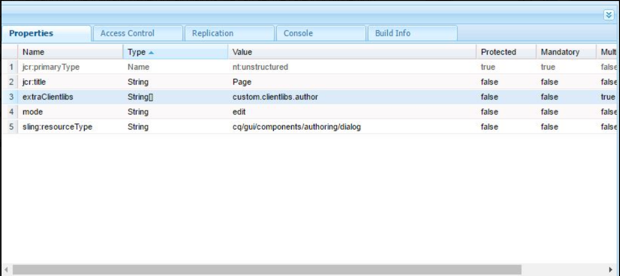

# Using includeClientLibs (granite UI component)

We can also use granite UI component - **/libs/granite/ui/components/coral/foundation/includeclientlibs**

For our custom clientlibs to be invoked for a particular dialog on page , we need to create a new node with any name and a property sling:resourceType=*"granite/ui/components/foundation/includeclientlibs"*

Add property – js – to load js specific clientlibs and the property value is the category of js clientlibs

Css – to load css specific clientlibs and the property value is the category of css clientlibs

# Useful Links

<http://rimamittal.blogspot.com/2017/06/extraclientlibs-in-aem.html>

Granite UI - <https://helpx.adobe.com/experience-manager/6-3/sites/developing/using/reference-materials/granite-ui/api/jcr_root/libs/granite/ui/components/coral/foundation/includeclientlibs/index.html>

WEM Git :

C:\projects\dcloud_feature\jcr\code\jcr_root\apps\cdc\framework\components\access-forms\wem_access_landing_pages\_cq_dialog\.content.xml

<https://wcmaem.blogspot.com/2016/08/how-to-load-touchui-dialog-specific.html>

<http://www.6dglobal.com/blog/resizing-touch-ui-component-dialogs-2016-01-07>

jcr\code\jcr_root\apps\r\cpdm\components\structure\basePage\_cq_dialog\.content.xml in **wem git**